Spring 2020 Water Quality Testing In The Hoosic River

Lauryn Rogers, Lexi Fappiano-Whalen, Jenna Crosier, Elena Traister, Cindy Delpapa

Massachusetts College of Liberal Art, Massachusetts Division of Ecological Restoration

Abstract

The Hoosic River in Massachusetts flows through- the city of North Adams and towns of Clarksburg, Williamstown and Adams, is a water source important to the natural environments of those towns. There are two branches that make up the Hoosic River; the south branch and the north branch. Located in both branches are dams and flood chutes that try to resolve any case of flooding that may happen. As the river flows through the city of North Adams and the other surrounding towns, it collects a variety of pollutants when rain and melting snow wash materials into storm drains emptying into the river, with a major concern being road salt. Currently the conductivity in the south branch is much higher than the north branch. Previous testing has shown the decline in water quality throughout the river. During the spring semester three students tested conductivity, salinity and continued the testing of total suspended sediment to assess the impact of the dam on sediment transport and to see what may be causing recently documented the water quality decline associated with a change in the macroinvertebrate community. The results showed that during dry weather there were higher conductivity readings and higher concentrations of sediment build up upstream of the dams.

Introduction
During the spring 2020 semester, we monitored the level of suspended sediment, conductivity, and salinity of the North and South branches of the Hoosic River. This river is an important natural resource for the surrounding towns. In the past students along with the Hoosic River Watershed Association have monitored the river and found questionable conductivity and sediment levels throughout the two branches, but mainly focusing on the south branch.
Previous testing by the students in Fall 2019 was focused on if the Suspended sediment was trapping in the dams and not being filtered through. They hypothesized that the river would have a higher amount of suspended sediment in wet weather than dry weather. Just like this semester, they tested for sediment in wet and dry weather to prove this hypothesis. The students concluded that their hypothesis was right and the river had a higher amount of sediment during wet weather.
For this semester’s research, we have come up with questions, based off of previous testing and research. One question is “ Where are sources of pollution that increase conductivity between the southern border of Adams and Galvin Rd. in North Adams?”. Another question is “How do dams influence sediment transport?”. The last question is “Do slugs of high chloride follow winter road salt applications and subsequent melt conditions?”. Throughout this semester, we have been collecting data to try and answer these three main questions.
Suspended sediment is the particles of materials such as stone fragments too small to be seen by the human eye and not heavy enough to be filtered out by gravity, thus staying suspended in the water. Suspended sediment is often collected behind dams, and in the case of the North Branch Hoosic River, these dams were built specifically to keep the suspended sediment from filling the flood chutes. If a dam is functioning well and is not full of sediment, the level of suspended sediment upstream of the dam will be higher than the level downstream of the dam. If the levels are very similar, it means the dam is no longer serving its purpose.
Dams don't only affect the sediment transport of a river but they are a disruption to surrounding ecosystems. Dams also block the migration pattern for fish species. This is a serious threat to species and can cause extinction to these species (Kondolf, et al. 2014).
Conductivity is water that is capable of passing through an electrical current.The conductivity is primarily affected by the water current and the “geology” of the river (EPA 2012). Conductivity testing allows for researchers to monitor the average conductivity in streams and rivers. When conductivity changes from what the average usually is, it allows for researchers to pinpoint the issue which could be pollution or other forms of river/stream disruption.
Two new things we monitored this semester were salinity and conductivity. Salinity is the level of salt in the water. This can be caused by many factors, mostly from salt being washed into the river from the roads by rain. Rivers are more susceptible to higher salt levels due to road salt, fertilizer and other sources of pollution ( Zhang 2018). We hypothesized that because of this, the level of salinity would be highest in wet samples. The conductivity deals with how well the sample conducts electricity. This can involve a number of factors, mostly the chemical components found in the water with salt being a good conductor. High conductivity can be a surrogate for elevated salinity. By comparing both, we can better see how our methods are working, and see the relation between the conductivity and salinity. This is because the Hoosic River Watershed association has raised concern about the big difference in conductivity between the South and North branch of the river.
We hypothesized that the concentration of suspended sediment would be higher directly before the dams than the concentration of suspended sediment directly after the dams. This would mean that the dams are still doing their job of collecting the sediment and keeping it from filling up the flood chutes but it also robs the downstream river of important building and repair materials. We would also compare those to the concentrations of previous years to see if the dams are still functioning as well now as they were in the past.

Methods

We used pre-existing long term sites used by previous students so we were able to capture flow above and below the dams to be able to test the hypothesis while also being accessible and safe to sample from. To test the conductivity we needed to think about safely collecting data with the YSI probe.

We collect the samples with a Van Dorn device, which allows us to capture around 2 liters of water at a specific depth of water. Water samples from each site were emptied into pre-labeled, with site number and date, liter sampling containers.

We also use a device called a YSI probe that is handheld to record the conductivity while out there. To collect conductivity we would place the probe into the river and wait for a consistent reading off of the YSI probe. The sampled water is then brought back to the lab so that it can be tested for salinity and sediment levels. When testing salinity, we used a dropper to drop one drop of water on the refractometer. In order to see clearly on the refractometer, we needed to use a lamp.

During each field data collection we recorded the time and date we collected the sample. We also recorded what type of weather condition we collected the sample in.

In order to test sediment levels, 1000 ML of the water is run through a pre-weighed and labelled filter paper using a vacuum to assist with the process of evaporation. The filters are then placed in an oven at 110 degrees Celsius for at least 24 hours to dry up any leftover water, and are then weighed. Using the before and after weights of each filter, we can determine the amount of suspended sediment in that location.

To analyze the sediment data we would take the average of all upstream wet weather data and subtract that from the average of the downstream wet weather data. We do the same for the dry weather data. For the conductivity data we took the averages for the upstream and downstream for both dry and wet weather.

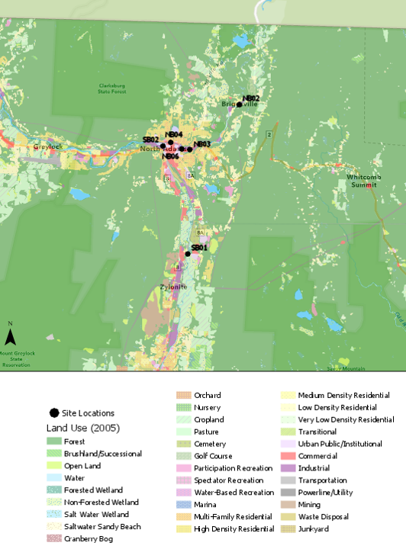

Results

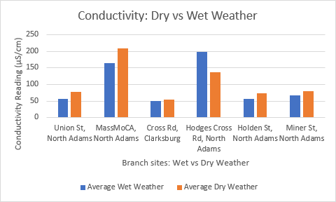

Figure 1. Conductivity (µS/cm) of wet and dry weather at each branch site.

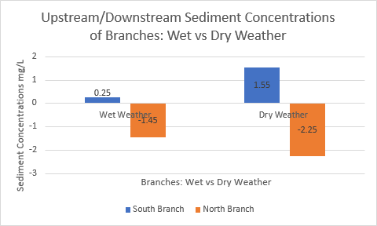
Figure 2. Sediment concentration of the river during wet and dry weather.

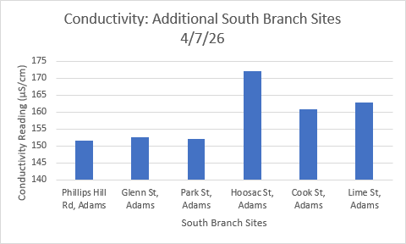
Figure 3. Conductivity (µS/cm) of additional South Branch sites.

Discussion

For the sediment data, we took the average difference of the immediate upstream and immediate downstream of each dam (South Branch and North Branch dam). Based on the data the South Branch has higher concentrations of sediment upstream of the dam during both wet and dry weather. During dry weather there is significantly higher sediment concentrations upstream of the dam during dry weather. The negative numbers on the North Branch represents higher sediment concentration downstream of the dam than upstream of the dam. This means that the North Branch dam is not doing as well preventing sediment transportation going from upstream to downstream.

We also found that the sediment concentrations were higher on days with dry weather than on days with wet weather. This could possibly be because there is less water but still the same amount of sediment, meaning it has less of a space to take up and that every amount of water has a higher percentage of it. The sediment load was higher when there was less water due to drier weather.

For salinity testing we used a refractometer which provides results in parts per thousand. When testing the water at each site for salinity, most of the data was 0. There was one day that was dry weather where the salinity was 2 ppt. Due to the low data, we do not know if there was an error in equipment, user error or there was just very low to no salt in the river. Though we did test the refractometer with our own salt water, perhaps the refractometer was just not sensitive enough, or was not tested properly with salt water.

On average conductivity was higher during dry weather likely due to less water dilution during wet weather. There was one day with South Branch site 1, conductivity was higher during wet weather. We believe that this has something to do with the salt from the road being washed into the river, but it would be interesting to see further research. Overall, conductivity in South Branch 2 was significantly higher during both wet and dry weather. Both South Branch sites have higher conductivity than the North Branch. The high conductivity results might be the reason that Hoosic River Watershed Association’s macroinvertebrate sampling showed degradation in the river, as the high conductivity made the water less inhabitable.

From Lime St to Phillips Hill Rd, those sites were only tested on one occasion. The data collected was pretty consistent from that one collection. There definitely needs to be further research for these sections. These sites were added after we collected most of the data from the other sites due to how, originally, we only had two south branch sites. These were additional south branch sites.

Literature Cited

EPA: https://archive.epa.gov/water/archive/web/html/vms59.html

Dams on the Mekong: Cumulative sediment starvation. Kondolf, GM; Z K Rubin; J T Minear, (2014) http://onlinelibrary.wiley.com/doi/10.1002/2013WR014651/full

The Atlantic: America’s Rivers are Getting Saltier. Sarah Zhang. (2018). https://www.theatlantic.com/science/archive/2018/01/americas-rivers-are-getting-saltier/549965/

